EXPERIMENT 8
ROLL NO: 240701533 NAME: SRITHIKA.S

Create storyboards to represent the user flow for your application using Balsamiq
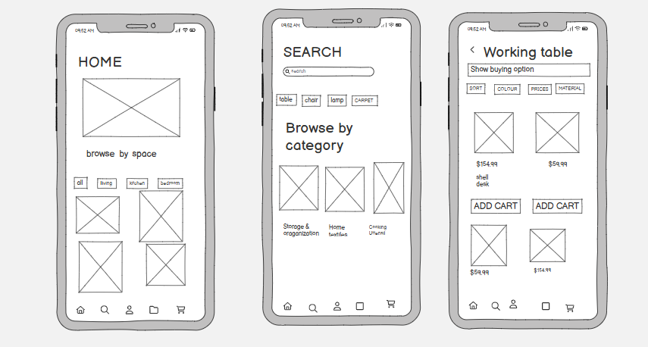1. Home Screen
- Title: HOME
- Large rectangle with “X” → placeholder for banner/product image
- Purpose:
Shows featured items, offers, or highlights when user opens the app.

2. Search Screen
- Title: SEARCH
- Search bar at top → user can type product names
- Category buttons: table, chair, lamp, carpet
- “Browse by” section → helps users explore categories easily

3. Product Listing Screen (Working Table)
- Title: Working table
- “Show buying option” → dropdown/filter
- Filters:
  - Sort
  - Colour
  - Prices
  - Material
- Product boxes (with X) → placeholders for items
Protype link:
https://balsamiq.cloud/su1662i/p5kpmj2

